

*December Issue YOUR DAILY NEWSPAPER*

*Season of Giving Month*

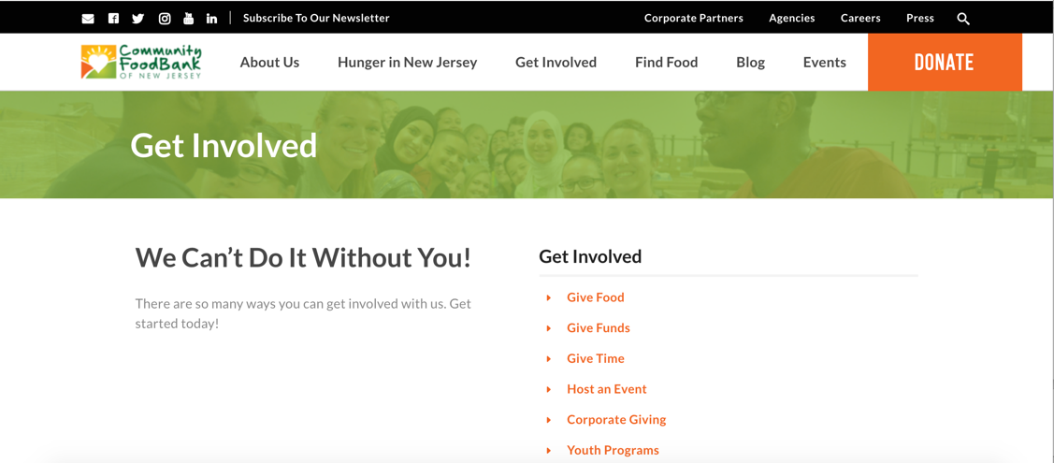

Visit the Community Food Bank of NJ for ways to get involved and give back during the holiday season.

http://www.cfbnj.org/get-involved?_ga=2.137262640.1656269344.1540564207-1711851234.1540564207



1. Send holiday cards to those serving in the military.
2. Provide a hands-on experience in fighting hunger and helping other kids.
3. Help fury friends by making homemade dog biscuits or toys for shelter dogs.

For more ways children can give back during the holiday season visit parenting.com.

https://money.usnews.com/money/blogs/my-money/articles/2016-11-16/6-ways-to-give-back-this-holiday-season

https://www.parenting.com/family-time/holidays/12-ways-children-can-give-back-holiday-season