August
2018

National Immunization Awareness Month
Sunday | Monday | Tuesday | Wednesday | Thursday | Friday | Saturday
 |  |  | 1 | 2 | 3 | 4
 |  |  | We all need shots (also called vaccinations or immunizations) to help protect us from serious diseases. |  | It’s important to know which shots you need and when to get them.
5 | 6 | 7 | 8 | 9 | 10 | 11
Shots can prevent serious diseases like the flu, measles, and pneumonia. |  | If you have a child age 6 or younger, find out which shots your child needs at https://www2a.cdc.gov/n ip/kidstuff/newscheduler _le/ |  | DYK? All adults need a Td booster shot every 10 years. Learn more about shots recommended for adults: http://1.usa.gov/16bENX2 |  | Talk to your doctor or nurse to make sure that everyone in your family gets the shots they need.
12 | 13 | 14 | 15 | 16 | 17 | 18
 | Everyone age 6 months and older needs to get a flu vaccine every year |  | Traveling soon? Find out if you need extra shots to stay safe: http://1.usa.gov/1Bjx8cc |  | Both boys and girls need to get the #HPV vaccines. Learn how the HPV vaccine can help keep your child safe: http://1.usa.gov/1JYFLdi | 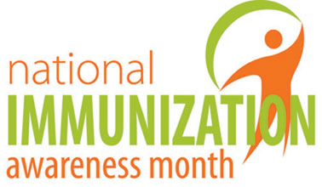
19 | 20 | 21 | 22 | 23 | 24 | 25
If you are pregnant, check out this recommended immunization schedule |  | Health tip: Keep a copy of your vaccination record in a safe place.
26 | 27 | 28 | 29 | 30 | 31
 | Use this chart for adults to see if you are up to date on your shots
For more information visit https://www.cdc.gov/vaccines/events/niam.html and https://www.cdc.gov/vaccines/index.html

