

*November Issue YOUR DAILY NEWSPAPER*

*Healthy Food Swaps Month*

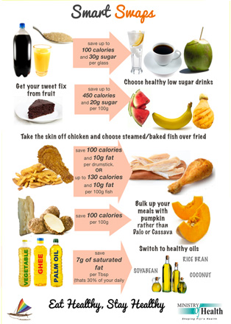

Center of Disease Control and Prevention Guidelines for adapting healthy eating behaviors

* **REFLECT** on all of your specific eating habits, both bad and good; and, your common triggers for unhealthy eating.
* **REPLACE** your unhealthy eating habits with healthier ones.
* **REINFORCE** your new, healthier eating habits.

https://www.cdc.gov/healthyweight/losing_weight/eating_habits.html

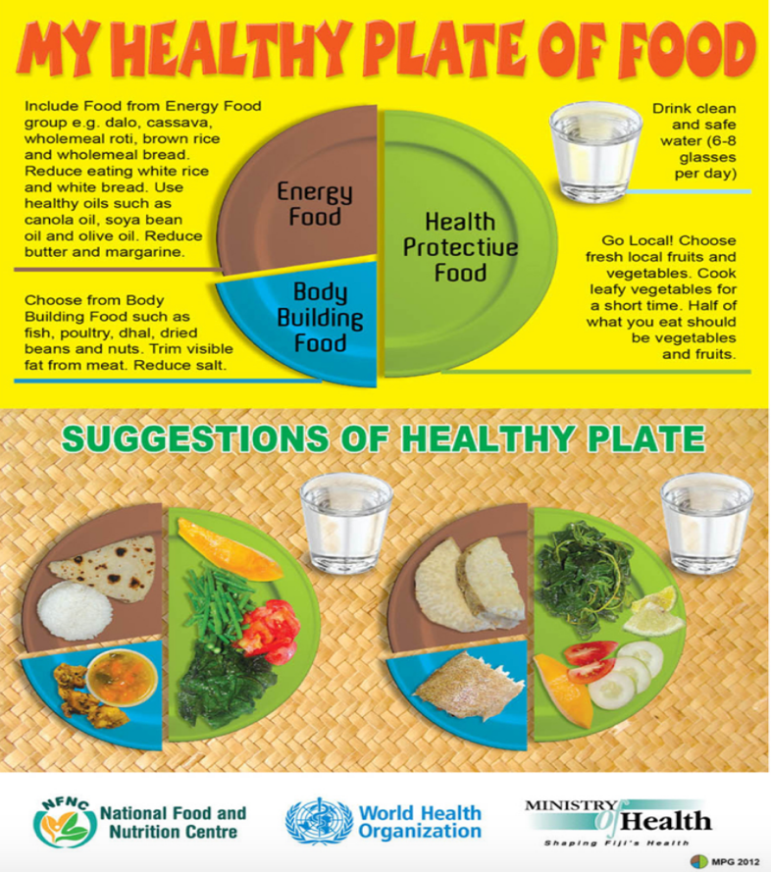

According to the National Diabetes Statistic Report

* In 2015, an estimated 1.5 million new cases of diabetes were diagnosed among U.S. adults aged 18 years or older.
* More than half of these new cases were among adults aged 45 to 64 years, and the numbers were about equal for men and women.

https://www.cdc.gov/diabetes/pdfs/data/statistics/national-diabetes-statistics-report.pdf

http://www.health.gov.fj/?page_id=1123